Asia-China-Coin-Bridge

Asia-China-Coin-Bridge Shape Currency Money, 桥 形 币钱 , Qiáo xíng Bì qián

Beautiful original patina, great condition, 91mm; 5.58 grams. The piercing is original and without cracks, holes or repairs. These were strung together, like the later holed cash. Zeno #6905; BM (Chinese Coins) #3.

This is the "rounded " type (with a rounded angle where the bridge bends). Chinese "bridge" money were among the earliest bronze Chinese coins. In the work of Coole (Coole, A. B., "An encyclopaedia of Chinese coins", Denver, 1967) these pieces are discussed under "Odd shaped mediums of exchange" where he suggests they were used in the transition period between the "bartering age and the coin age." Such examples were made in many shapes and resembled various valuable utensils and objects of the period including bells, lotus roots, knives, shields etc. This would explain why the shape of this example resembles early jade instruments called "chin", which were used like modern metallic triangles. Such examples are representative of the earliest phase of money-like exchange known in the world, and considering not much is definitively understood of these objects, they are perhaps best referred to as examples of proto-money. This coin is unconditionally guaranteed to be authentic.

(wvar5007) 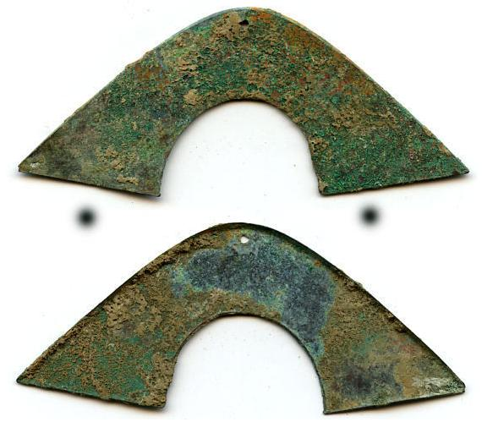

Beautiful original patina, great condition, 91mm; 5.58 grams. The piercing is original and without cracks, holes or repairs. These were strung together, like the later holed cash. Zeno #6905; BM (Chinese Coins) #3.

This is the "rounded " type (with a rounded angle where the bridge bends). Chinese "bridge" money were among the earliest bronze Chinese coins. In the work of Coole (Coole, A. B., "An encyclopaedia of Chinese coins", Denver, 1967) these pieces are discussed under "Odd shaped mediums of exchange" where he suggests they were used in the transitionary period between the "bartering age and the coin age". Such examples were made in many shapes and resembled various valuable utensils and objects of the period including bells, lotus roots, knives, shields etc. This would explain why the shape of this example resembles early jade instruments called "chin", which were used like modern metallic triangles. Such examples are representative of the earliest phase of money-like exchange known in the world, and considering not much is definitively understood of these objects, they are perhaps best referred to as examples of proto-money. This coin is unconditionally guaranteed to be authentic.

(wvar5007) 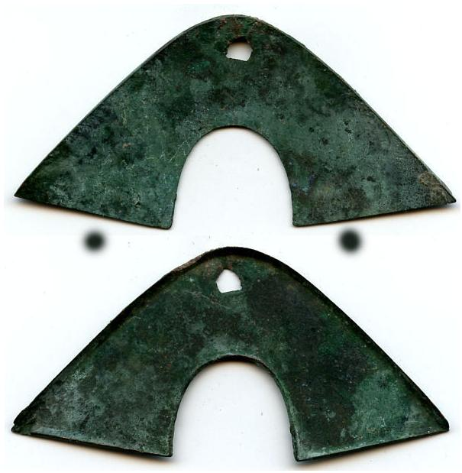Beautiful original patina, great condition, 98mm; 9.89 grams. The piercing is original and without cracks, holes or repairs. These were strung together, like the later holed cash. Zeno #6905; BM (Chinese Coins) #3.

This is the "rounded " type (with a rounded angle where the bridge bends). Chinese "bridge" money were among the earliest bronze Chinese coins. In the work of Coole (Coole, A. B., "An encyclopaedia of Chinese coins", Denver, 1967) these pieces are discussed under "Odd shaped mediums of exchange" where he suggests they were used in the transitionary period between the "bartering age and the coin age". Such examples were made in many shapes and resembled various valuable utensils and objects of the period including bells, lotus roots, knives, shields etc. This would explain why the shape of this example resembles early jade instruments called "chin", which were used like modern metallic triangles. Such examples are representative of the earliest phase of money-like exchange known in the world, and considering not much is definitively understood of these objects, they are perhaps best referred to as examples of proto-money. This coin is unconditionally guaranteed to be authentic.

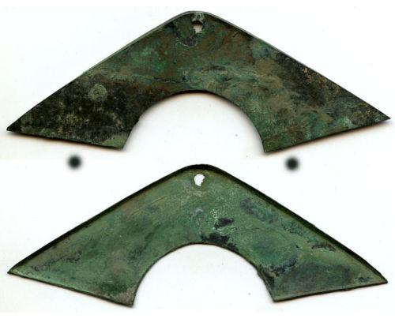

Beautiful original patina, great condition, 131mm; 10.04 grams. The piercing is original and without cracks, holes or repairs. These were strung together, like the later holed cash. Zeno #6905; BM (Chinese Coins) #3.

This is the "angled" type (with a sharp angle where the bridge bends). Chinese "bridge" money were among the earliest bronze Chinese coins. In the work of Coole (Coole, A. B., "An encyclopaedia of Chinese coins", Denver, 1967) these pieces are discussed under "Odd shaped mediums of exchange" where he suggests they were used in the transitionary period between the "bartering age and the coin age". Such examples were made in many shapes and resembled various valuable utensils and objects of the period including bells, lotus roots, knives, shields etc. This would explain why the shape of this example resembles early jade instruments called "chin", which were used like modern metallic triangles. Such examples are representative of the earliest phase of money-like exchange known in the world, and considering not much is definitively understood of these objects, they are perhaps best referred to as examples of proto-money. This coin is unconditionally guaranteed to be authentic.

(wvar50081)

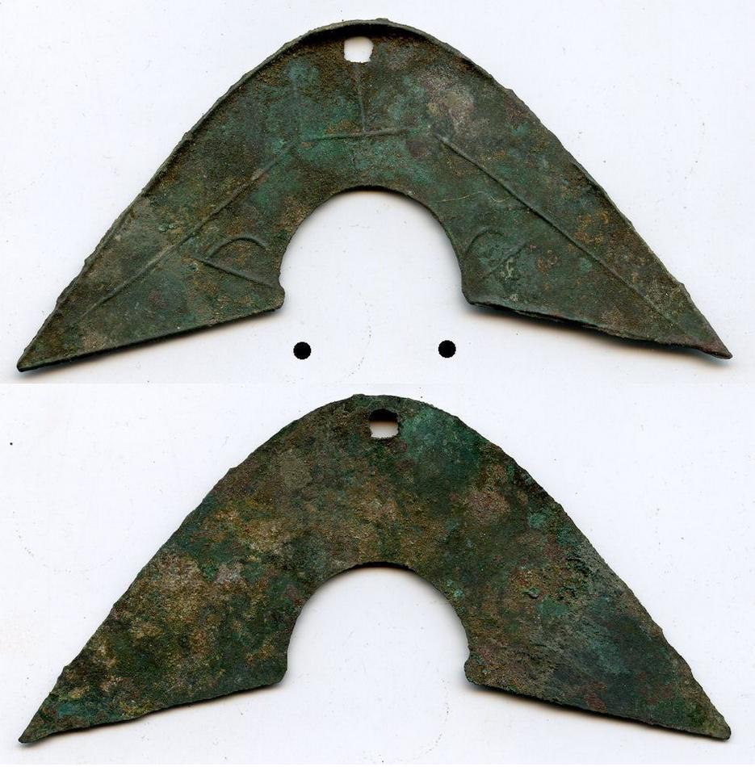

Decorated with a line pattern (and a possible word "Shan") on one side. Beautiful original patina, great condition, 113mm long, 10.71 grams.

The piercing is original - these were strung together, like the later holed cash. Zeno #10380 or similar; BM (Chinese Coins) #- (chapter 1). Very rare decorated type. Decorated pieces, like this one, are hard to find. This piece has a beautiful patina and does not have any visible flaws or repairs. Chinese "bridge" money were among the earliest bronze Chinese coins. In the work of Coole (Coole, A. B., "An encyclopaedia of Chinese coins", Denver, 1967) these pieces are discussed under "Odd shaped mediums of exchange" where he suggests they were used in the transitionary period between the "bartering age and the coin age". Such examples were made in many shapes and resembled various valuable utensils and objects of the period including bells, lotus roots, knives, shields etc. This would explain why the shape of this example resembles early jade instruments called "chin", which were used like modern metallic triangles. Such examples are representative of the earliest phase of money-like exchange known in the world, and considering not much is definitively understood of these objects, they are perhaps best referred to as examples of proto-money. This coin is unconditionally guaranteed to be authentic. (wvar1830)

